**8 SCIENCE ASSIGNMENT 2016**

THE ALCHEMISTS

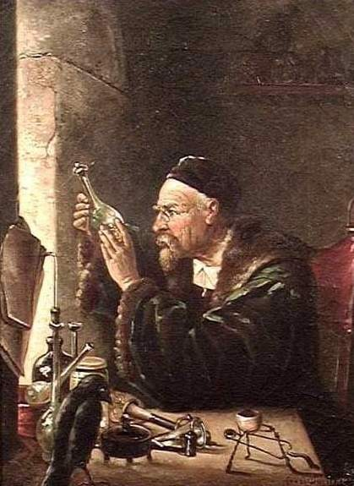

Name:__________________ Teacher:__________________

Form:__________________ Due date:_________________

**Plagiarism**

You must write in ***your own words***, not copy sentences word for word from another student or another source.

Plagiarising = instant zero on assignment and you will have to re-do it.

**Assessment policy**

Give me a sick note/legitimate reason from parent BEFORE due date = new negotiated due date.

One day late = -20% taken off mark

Two days late = -40% taken off mark

Three days late = mark of zero given, students are required to attend a detention and are still required to submit the assignment.

**If you are not at school the day this assignment is due, please email this booklet to me by 4pm on the due date.**

**____________________@aranmore.wa.edu.au**

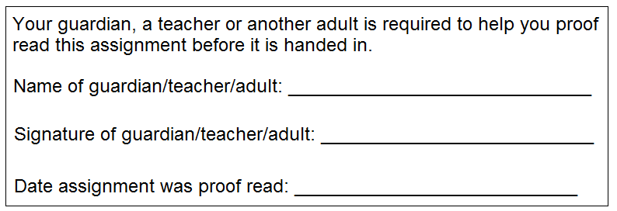

**Introduction**

Today, the study of physical and chemical changes is called chemistry and the people who study them are known as chemists. Before chemistry, the study of physical and chemical changes was surrounded by myth and magic. These studies were performed by a group of people called alchemists. Today, scientists know that most of the things alchemists tried to achieve are technically impossible, however, many of the techniques they developed become the foundations of modern chemistry.

**Aim:** This assignment will allow you to find out about the alchemists and some of the legends and myths in alchemy.

**Recommended resources**

 Video: Out of the Fiery Furnace - Episode 6 - 4:05min

 Video: The Real Sorcerer’s Stone Documentary - 44:29min: https://www.youtube.com/watch?v=vFPQITnN2dE

 End of chapter 6.4 in the 8 science e-book has information on the alchemists.

1. State where the word ‘alchemy’ originates from and explain what the word means. (2 marks)

_______________________________________________________________________________________________

_______________________________________________________________________________________________

_______________________________________________________________________________________________

_______________________________________________________________________________________________

2. Alchemists studied physical and chemical change by trial and error rather than using scientific method.

Explain what this means. (2 marks)

_______________________________________________________________________________________________

_______________________________________________________________________________________________

_______________________________________________________________________________________________

_______________________________________________________________________________________________

_______________________________________________________________________________________________

_______________________________________________________________________________________________

_______________________________________________________________________________________________

3. Alchemists tried to change metals from one type to another. Outline which specific metals they were trying to change and what they were hoping they would change into. (2 mark)

_______________________________________________________________________________________________

_______________________________________________________________________________________________

_______________________________________________________________________________________________

_______________________________________________________________________________________________

_______________________________________________________________________________________________

4. Alchemists tried to discover the panacea, universal solvent, and the elixir of life. Describe what each of these were. (Minimum of two sentences each). (6 marks)

Panacea: _______________________________________________________________________________________

_______________________________________________________________________________________________

_______________________________________________________________________________________________

_______________________________________________________________________________________________

_______________________________________________________________________________________________

_______________________________________________________________________________________________

Universal solvent: ________________________________________________________________________________

_______________________________________________________________________________________________

_______________________________________________________________________________________________

_______________________________________________________________________________________________

_______________________________________________________________________________________________

_______________________________________________________________________________________________

Elixir of life: _____________________________________________________________________________________

_______________________________________________________________________________________________

_______________________________________________________________________________________________

_______________________________________________________________________________________________

_______________________________________________________________________________________________

_______________________________________________________________________________________________

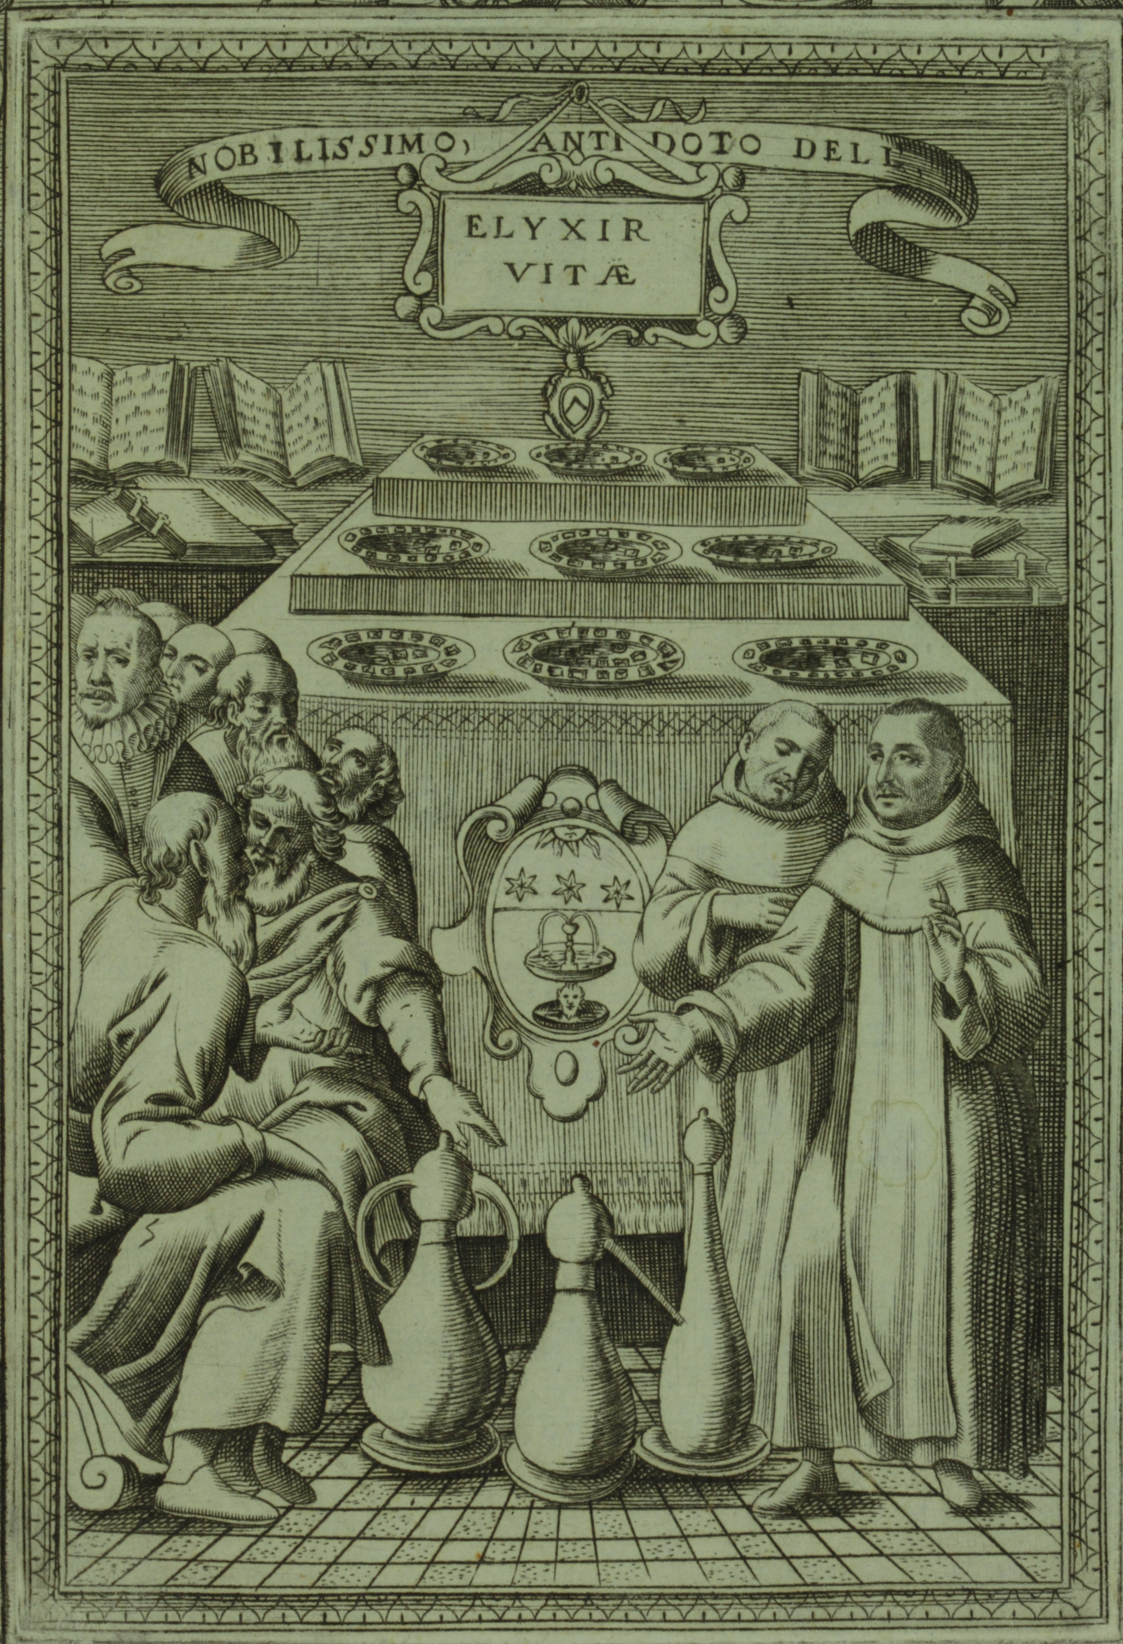

This is a an etch called ‘Dell’ elixir vitae’ from 1624, which translates to ‘Elixir of Life’.

5. The Philosopher’s Stone is one of the most well-known myths of the alchemists. Describe what the Philosopher’s Stone was, why it was one of the most sought after objects by alchemists in Europe, and what it was thought to be able to do. (Write in full sentences). (3 marks)

_______________________________________________________________________________________________

_______________________________________________________________________________________________

_______________________________________________________________________________________________

_______________________________________________________________________________________________

_______________________________________________________________________________________________

_______________________________________________________________________________________________

_______________________________________________________________________________________________

6. Western alchemists used symbols to represent the four Greek elements. State the four elements and draw their symbol next to each one. (8 marks)

7. Explain one key difference between alchemy and modern science. (2 marks)

(Minimum of two sentences).

_______________________________________________________________________________________________

_______________________________________________________________________________________________

_______________________________________________________________________________________________

_______________________________________________________________________________________________

_______________________________________________________________________________________________

_______________________________________________________________________________________________

Choose one (1) of the following well-known alchemists below and find out the following information.

 Jan Baptist van Helmont  John Dee  Muhammad ibn Zakariyā Rāzī

1. Date of birth: _________________________________________________________________________ (1 mark)

2. Place of birth: _________________________________________________________________________ (1 mark)

3. Date of death: ________________________________________________________________________ (1 mark)

4. Write a brief biography of your chosen alchemist (can include early life, marriage, children, education etc.).

(Minimum of three sentences). (4 marks)

_______________________________________________________________________________________________

_______________________________________________________________________________________________

_______________________________________________________________________________________________

_______________________________________________________________________________________________

_______________________________________________________________________________________________

_______________________________________________________________________________________________

_______________________________________________________________________________________________

_______________________________________________________________________________________________

_______________________________________________________________________________________________

_______________________________________________________________________________________________

_______________________________________________________________________________________________

5. Describe one way that your chosen alchemist contributed to science. (1 mark)

(Minimum of two sentences).

_________________________________________________________________________________________________

_________________________________________________________________________________________________

_________________________________________________________________________________________________

_________________________________________________________________________________________________

_________________________________________________________________________________________________

_________________________________________________________________________________________________

_________________________________________________________________________________________________

_________________________________________________________________________________________________

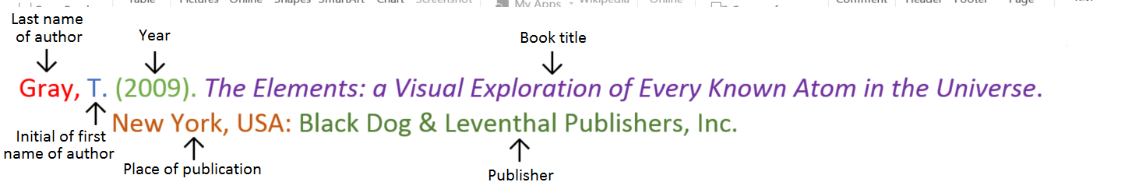**Book**

**Book with two authors**

Shermer, M., & Benjamin, A. (2006). *Secrets of Mental Math: The Mathemagician’s Guide to Lightning Calculation and Amazing Mental Math Tricks*. New York, USA: Three Rivers Press.

**Book with three or more authors**

Bulliet, R. W., Alley, R. B., Broecker, W. S., & Denton, G. H. (2011). *The fate of Greenland: Lessons from abrupt climate change*. Cambridge, MA: MIT Press.

**Book with editor**

Kasdorf, W. E. (Ed). (2003). *The Columbia guide to digital publishing*. New York, USA: Columbia University Press.

**Book with different editions**

Nagle, G., & Cooke, B. (2012). *Geography Study Guide: Oxford Ib Diploma Programme* (2nd ed.). Oxford, UK: Oxford University Press.

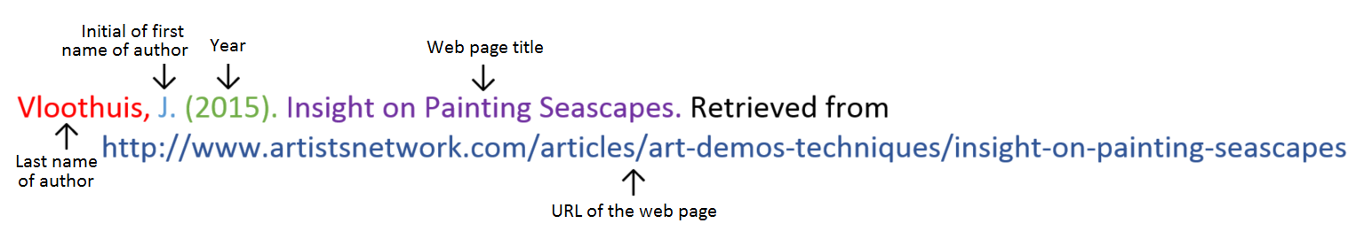**Website**

**Website with no author** (put title of page at the front)

Aranmore Catholic College. (2014). Retrieved from

http://www.aranmore.wa.edu.au/

**Website with no date**

The Zadkine Museum. (n.d). Retrieved from http://www.france.fr/en/museums/zadkine- museum.html

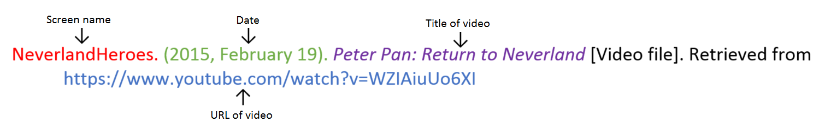**Video file**

**Reference list**

Minimum of two references. (1 mark)

Minimum of two different sources (1 mark)

(Book, encyclopedia, video, website, journal, magazine, newspaper etc.).

Referenced using the APA style on the previous page. (1 mark)

**Note: Wikipedia will not be accepted as a reference.**

_______________________________________________________________________________________________

_______________________________________________________________________________________________

_______________________________________________________________________________________________

_______________________________________________________________________________________________

_______________________________________________________________________________________________

_______________________________________________________________________________________________

_______________________________________________________________________________________________

_______________________________________________________________________________________________

_______________________________________________________________________________________________

_______________________________________________________________________________________________

Assignment is neatly written or typed. (1 mark)

Correct spelling and grammar. (1 mark)

/38 Mark as percentage: %

Teacher comment: on Seqta